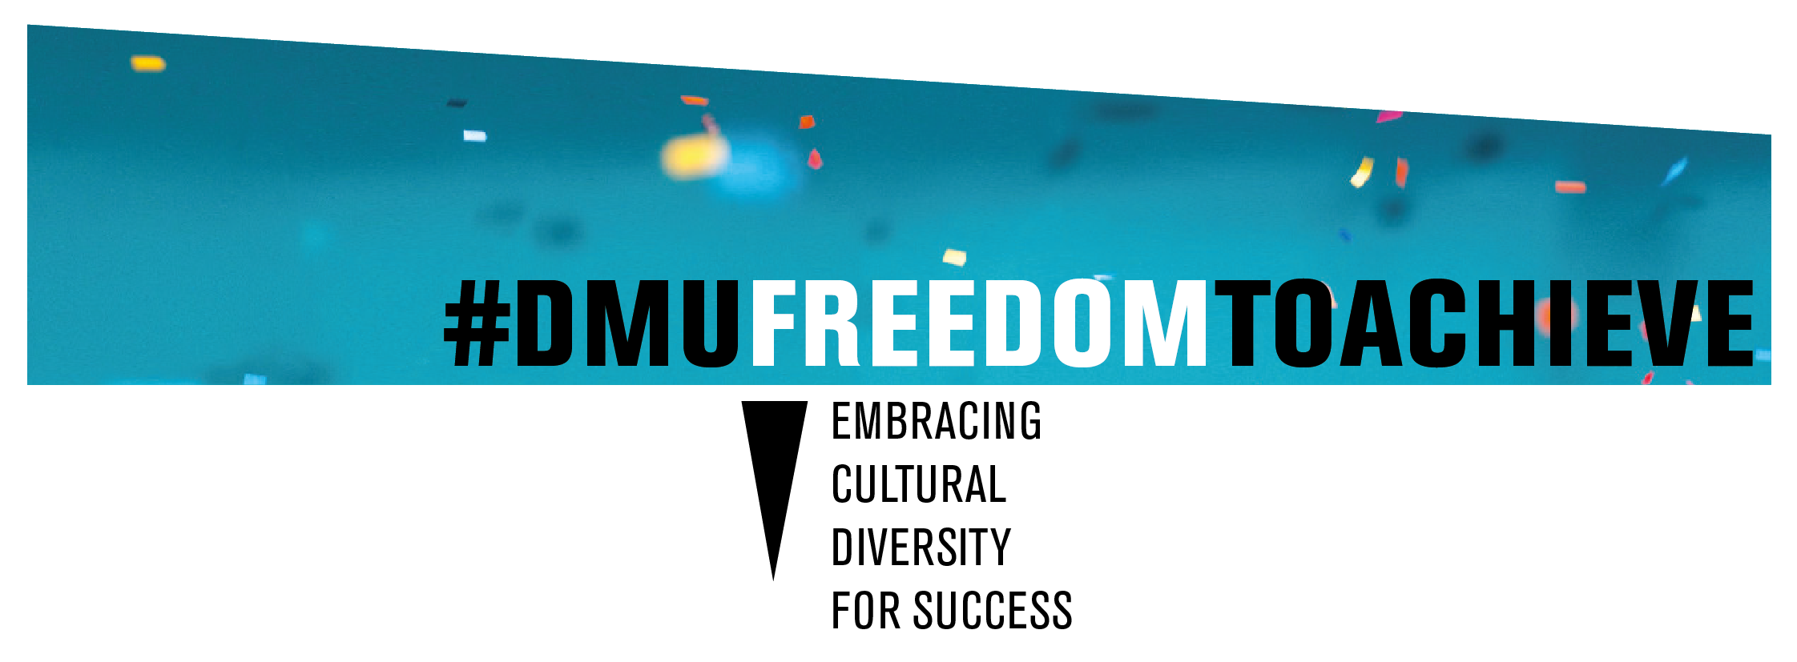

FTA Team Talks 18/19
Kaye Towlson and Bernie Gregory
- Opportunity to share good practice working towards closure of the attainment gap
- Discover the breadth of DMU interventions to close the BAME attainment gap
- First work of year: support, assessment type 20/11/18
- Retention , establishing connection/belonging 8/1/19
- Establishing engagement and confidence 19/2/19
- Curriculum development and employability 25/6/19

Tuesday 9/10/18: Transition and support: New year, new ideas:
Supporting Student Wellbeing to Maximise Performance (Nicola Ward, School of Pharmacy)
10 top tips to engage students (Geoff Hughes: Academic Learning & OD Consultant POD)

Tuesday 20/11/18 First work of year: support, assessment type :
Opening doors to a more inclusive future
- Writing for diversity: Susie Day RLF Fellow and children’s author: impact of a ‘single story’ on the reader, the surprising challenges facing BAME creatives. An interactive session inviting you to explore your own childhood experiences, and consider how you might open your own ‘windows’ and ‘doors’ to an inclusive future.
- Bernie Gregory: Nursing and midwifery Lecturer, HLS Fair Outcomes Champion: Ideas for Co creation; demystifying assessment guidelines and “Fit to submit? “.

8/1/19 Retention, connection and belonging: “Observe and wonder”:
Using DMU Replay for more than lecture capture Dr. Kim Fisher (Senior Lecturer Pharmacy)
'Observe and wonder - and tell us all about it': Applying subject knowledge to the real world in assessed blogs.
Dr. Anu Koskela (Senior Lecturer, English Language)
26/2/19 FTA Team Talks: Establishing engagement and confidence”
Image is the servant , David Soden, Photography
Academic English and the attainment gap , Sumeya Loonat English and creative Writing

25/6/19 Curriculum development and employability
“Tree of Life” Alice Simon (Senior Lecturer Psychology)
Expanding research methodologies; using Hajj diaries Olivier De Condappa (Senior Lecturer, Psychology)
“Wall of Fame” Nicky Harding (Senior Lecturer Interior Design)
“Self Portrait” Teodora Kuzmanova (Senior Lecturer Game Art)

Missed themes: (April and May: due to Easter, exams and availability)
Co-creation and reflective practice
Exams, finals and alternative assessments KT/5/7/19

